# OpenFOAM (Open-Source Version) Compilation Instructions

## I. Instructions before compiling

1. This solver is based on OpenFOAM-6, so please install OpenFOAM-6 before compiling this solver;
2. Copy the zip file "fasion-6" to the existing OpenFOAM folder and extract it to get the folder "fasion-6".



It should be noted that "fasion" is the author's username, and you need to change the "fasion" to the username of your own system after the copy is completed.

## II. Compilation process

1. Enter directory "fasion-6\run\1-bc\caoliuConvectionFvPatchScalarField", run command "wmake";
2. Enter directory "fasion-6\run\0-solvers\singleLaserSLMCaoLiuFoam\incompressible", run command "wmake";
3. Enter directory "fasion-6\run\0-solvers\singleLaserSLMCaoLiuFoam\immiscibleIncompressibleTwoPhaseMixture", run command "wmake";
4. Enter directory "fasion-6\run\0-solvers\singleLaserSLMCaoLiuFoam\TurbulenceModels\incompressible", run command "wmake";
5. Enter directory "fasion-6\run\0-solvers\singleLaserSLMCaoLiuFoam\singleLaserSLMCaoLiuFoam", run command "wmake";
6. Enter directory "fasion-6\run\0-solvers\multiLaserSLMCaoLiuFoam\multiLaserSLMCaoLiuFoam", run command "wmake";
7. So far, Four custom library files will appear under the directory "fasion-6\platforms\linux64GccDPInt32Opt\lib", and two custom solvers will appear under the directory "fasion-6\platforms\linux64GccDPInt32Opt\bin". The compilation is complete.

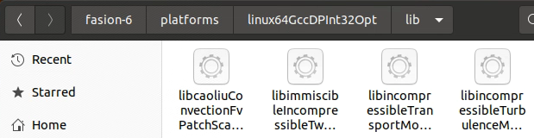

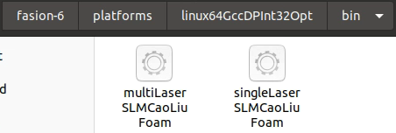

## III. Use of the solvers

1. In the directory "fasion-6\run\2-case", there are two solver cases. test_multiLaserSLMCaoLiuFoam is used to predict the SLM forming process under the action of a single laser, and test_singleLaserSLMCaoLiuFoam is used to predict the SLM forming process under the action of multiple lasers;
2. Enter the folder "fasion-6\run\2-case\test_singleLaserSLMCaoLiuFoam", run the command "./Allrun_noParallel" to start single-core computation (if it doesn't work, please run "chmod +x Allrun_noParallel" first, then run "./Allrun_noParallel"), run "./Allrun_parallel" to start multi-core computation (if it doesn't work, please run "chmod +x Allrun_parallel" first, then run "./Allrun_parallel"; it is recommended to use multi-core computation for large amount of computation). The result of computation at a certain moment is as follows:

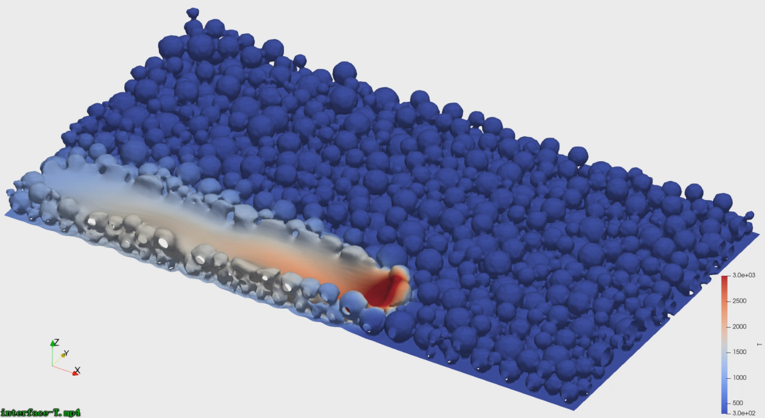

1. Enter the folder "fasion-6\run\2-case\test_multiLaserSLMCaoLiuFoam", run the command "./Allrun_noParallel" to start single-core computation (if it doesn't work, please run "chmod +x Allrun_noParallel" first, then run "./Allrun_noParallel"), run "./Allrun_parallel" to start multi-core computation (if it doesn't work, please run "chmod +x Allrun_parallel" first, then "./Allrun_parallel" command; it is recommended to use multi-core computation for large amount of computation). The result of the computation at a certain moment is as follows:

